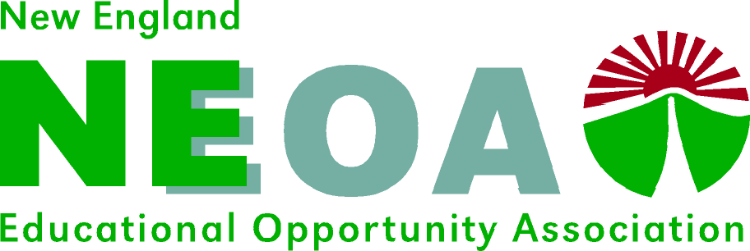

NEOA State Initiative Grant Funds Proposal Form 2023-2024

Proposals are accepted on a rolling basis until August 1, 2024 as funds allow, and decisions are made within a month of the proposal. Project activities for 2023-24 should conclude by August 2024. Reimbursement requests must be made within thirty days of project completion and before August 1.

Please submit the proposal online at sarah.morrell@umb.edu or to sarahannmorrell@gmail.com to Sarah Morrell, Chair, NEOA Advocacy Committee. For more information, please contact the Chair. It is anticipated that at least one award per state will be made, if possible. State leaders may apply on behalf of NEOA member states, and individuals may also apply for funds for state advocacy activities.

PLEASE COMPLETE THIS FORM.

Date:

State Association:

Project Title:

Grant Period:

Project Contact:

Name:

Title:

Address:

Email:

PROJECT SUMMARY

Please describe in detail the activity, the resources and budget needed, the potential impact on the state/region, and planned evaluation measures.
Please address how this proposal meets the stated priorities of the NEOA Association. Thank you.

Budget:

Total requested:

Will you be requesting COE Spraggins matching funds for this activity?

